**Project Name: Grocerwala**

**Project Member:**

**Shweth Kenkre 220343120047**

**Tejas Shrirao 220343120107**

**Akshay Kolhe 220343120049**

**Lakshya Pareek 220343120053**

**Abstract:**

Grocerwala is a site where you can order grocery from your near by general store sitting at home. This site allows you to select the grocery which are available at the general store sitting at home. You can collect it from the General Store. This site will show you the available options of food and household supplies at the store and allows you to place an order at store at a time. Summary of your particular order will be sent and you can pay the bill by QR or Phone number of the general store or by Cash at time of picking up the grocery. As soon as the marketer pack the grocery the notification will sent on your register number or on site from which the person placed the order. As the Marketer will have less customers to deal with and will be able to work faster comparatively and the customer wont have to wait for very long time at the general store . And the customer will be able to select whatever they want without wasting time for waiting in queues.

**Implementation Technologies:**

1. **Spring Boot Framework:**

Spring Boot Framework is a Java platform that provides comprehensive infrastructure support for developing Java applications. Spring Boot handles the infrastructure so you can focus on your application.

Spring Boot enables you to build applications from “plain old Java objects” (POJOs) and to apply enterprise services non-invasively to POJOs. This capability applies to the Java SE programming model and to full and partial Java EE.

**1.1 Features of Spring Framework:**

**1. Lightweight**

Spring is modular lightweight framework which allows you to selectively use any of its modules on the top of Spring Core.

**2. Inversion of Control (IOC)**

This is another top feature of Spring Boot framework where application dependencies are satisfied by the framework itself. Framework creates the object in runtime and satisfies application dependencies.

**3. Container**

Spring provides their own container for managing the bean lifecycle.

**4. MVC Framework**

Spring MVC Framework is used for developing MVC based web applications.

**5. Transaction Management**

Spring Boot framework provides generic Transaction Management layer which can be used with or without J2EE(JEE) environment.

**1.2 Advantages of Spring Boot Framework:**

**1. Solving difficulties of Enterprise application development**

Spring is solving the difficulties of development of complex applications, it provides Spring Core, Spring IoC and Spring AOP for integrating various components of business applications.

**2. Support Enterprise application development through POJOs**

Spring supports development of Enterprise application development using the POJO classes which removes the need of importing heavy Enterprise container during development. This makes application testing much easier.

**3. Easy integration other frameworks**

Spring designed to be used with all other frameworks of Java, you can use ORM, Struts, Hibernate and other frameworks of Java together. Spring framework do not impose any restriction on the frameworks to be used together.

**4. Application Testing**

Spring Container can be used to develop and run test cases outside enterprise container which makes testing much easier.

**5. Modularity**

Spring framework is modular framework and it comes with many modules such as Spring MVC, Spring ORM, Spring JDBC, Spring Transactions etc. which can used as per application requirement in modular fashion.

**6. Spring Transaction Management**

Spring Transaction Management interface is very flexible it can configure to use local transactions in small application which can be scaled to JTA for global transactions.

**2.1** **MySQL**

MySQL, the most popular Open Source SQL database management system, is developed, distributed, and supported by Oracle Corporation.

**Features of MySQL:**

* **MySQL is a database management system.**

A database is a structured collection of data. It may be anything from a simple shopping list to a picture gallery or the vast amounts of information in a corporate network. To add, access, and process data stored in a computer database, you need a database management system such as MySQL Server. Since computers are very good at handling large amounts of data, database management systems play a central role in computing, as standalone utilities, or as parts of other applications.

* **MySQL databases are relational.**

A relational database stores data in separate tables rather than putting all the data in one big storeroom. The database structures are organized into physical files optimized for speed. The logical model, with objects such as databases, tables, views, rows, and columns, offers a flexible programming environment.

* **MySQL software is Open Source.**

Open Source means that it is possible for anyone to use and modify the software. Anybody can download the MySQL software from the Internet and use it without paying anything.

* **The MySQL Database Server is very fast, reliable, scalable, and easy to use.**

MySQL Server was originally developed to handle large databases much faster than existing solutions and has been successfully used in highly demanding production environments for several years. Although under constant development, MySQL Server today offers a rich and useful set of functions. Its connectivity, speed, and security make MySQL Server highly suited for accessing databases on the Internet.

* **MySQL Server works in client/server or embedded systems.**

The MySQL Database Software is a client/server system that consists of a multithreaded SQL server that supports different back ends, several different client programs and libraries, administrative tools, and a wide range of application programming interfaces (APIs).

1. **Hardware and Software Requirements (Minimum):**

**Hardware:**

1. Intel i3 processor 3rd generation

4. 1Tb GB HDD Space

5. SSD-256GB

**Software:**

1. Eclipse 4.7 Oxygen
2. MySQL 5.7 with Workbench 8.0
3. Visual Studio Code
4. Windows(10 or above)
5. Apache Tomcat Server 8.5
6. Maven Dependencies
7. **ER Diagram:**

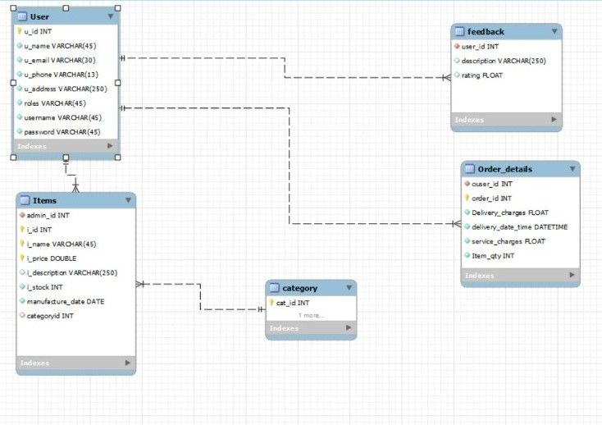

Figure 1: ER Diagram

**3.1 ERD Diagram/ Database Table**

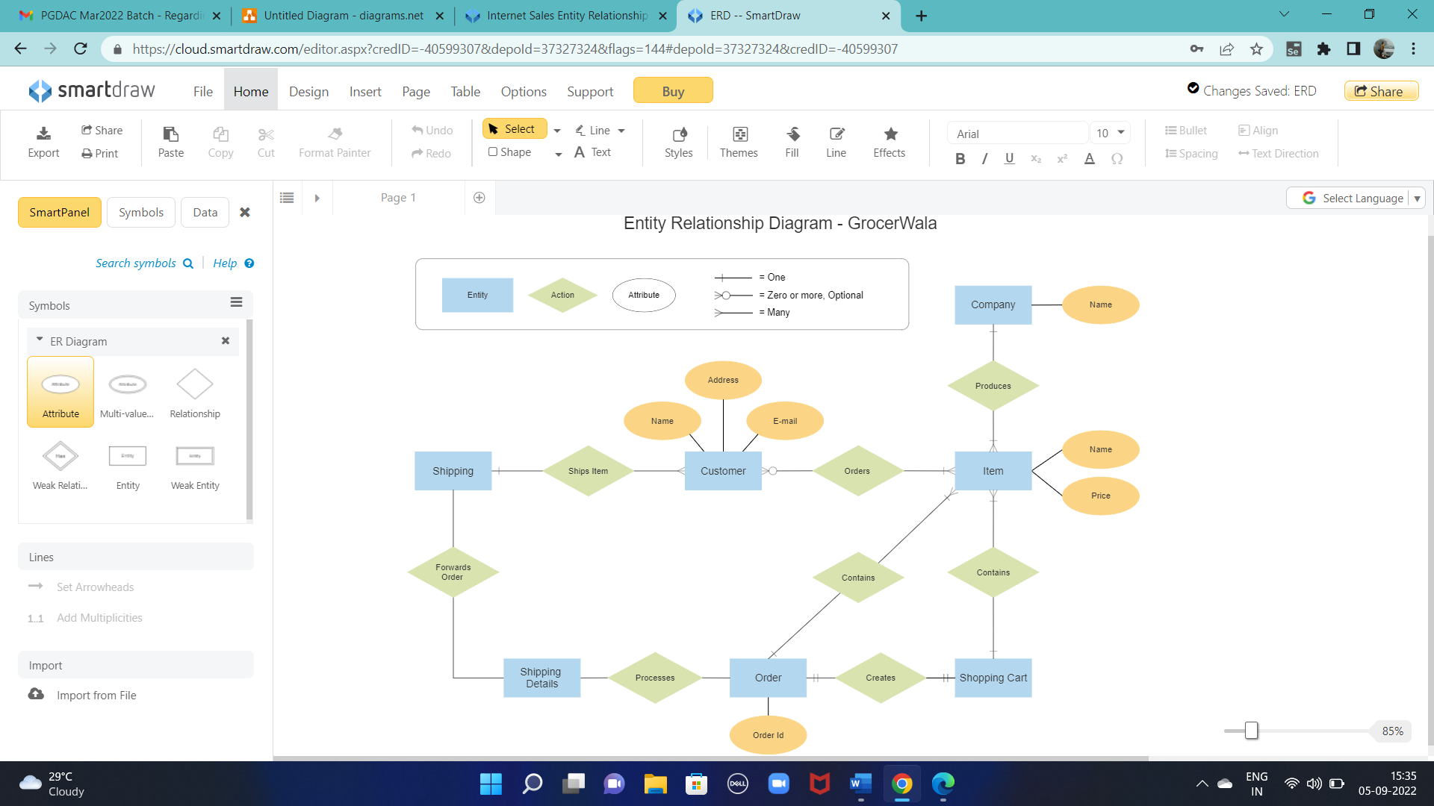

1. **Table Structures:**
2. **Table name:-User**

|  |  |  |  |  |
| --- | --- | --- | --- | --- |
| **Field** | **Type** | **Null** | **Key** | **Extra** |
| u_id | int | NO | PRI | auto_increment |
| u_name | varchar(45) | NO |  |  |
| u_email | varchar(30) | NO |  |  |
| u_phone | varchar(13) | NO |  |  |
| u_address | varchar(250) | NO |  |  |
| roles | varchar(45) | NO |  |  |
| username | varchar(45) | NO |  |  |
| password | varchar(45) | NO |  |  |

1. **Table name:- Category**

|  |  |  |  |  |
| --- | --- | --- | --- | --- |
| **Field** | **Type** | **Null** | **Key** | **Extra** |
| cat_id | int | NO | PRI | auto_increment |
| cat_name | varchar(45) | NO |  |  |

1. **Table name:-Items**

|  |  |  |  |  |
| --- | --- | --- | --- | --- |
| **Field** | **Type** | **Null** | **Key** | **Extra** |
| admin_id | int | NO | MUL |  |
| i_id | int | NO | PRI | auto_increment |
| i_name | Varchar(45) | NO | PRI |  |
| i_price | DOUBLE | NO | PRI |  |
| i_description | Varchar(25) | NO |  |  |
| i_stock | int | NO |  |  |
| manufacture_date | DATE | NO |  |  |
| categoryid | int | NO | MUL |  |

1. **Table name:-Order_details**

|  |  |  |  |  |
| --- | --- | --- | --- | --- |
| **Field** | **Type** | **Null** | **Key** | **Extra** |
| ouser_id | Int | NO | MUL |  |
| order_id | Int | NO | PRI | auto_increment |
| Delivery_charges | FLOAT | NO |  |  |
| delivery_date_time | DATETIME | NO |  |  |
| service_charges | FLOAT | NO |  |  |
| item_qty | Int | NO |  |  |

1. **Table name:-Feedback**

|  |  |  |  |  |
| --- | --- | --- | --- | --- |
| **Field** | **Type** | **Null** | **Key** | **Extra** |
| user_id | int | NO | MUL |  |
| description | Varchar(250) | NO |  |  |
| rating | FLOAT | NO |  |  |

1. **Future Scope of Project:**

Improvement in design, User and vendor verification, Net banking/UPI payments,Mobile application,chat bot.

**Thank You!**